# Lophophorata

Lophophorata includes three taxa for which we may have living specimens, Phoronida, Bryozoa, and Brachiopoda These clades possess a funnel-shaped anterior ring of ciliated tentacles known as a lophophore . The lophophore surrounds the mouth and is an upstream collecting system for suspension feeding. Its tentacles are hollow with extensions of a coelomic space thought to be a mesocoel. The gut is U-shaped with the anterior mouth at the center of the lophophore. The anus is also anterior, but is dorsal to the mouth, **outside the ring of the lophophore**.

The lophophoral tentacles bear two types of cilia. Frontal cilia on the inside face of the tentacles extend into the interior of the lophophore, whereas lateral cilia on the sides of the tentacles extend into the gap between adjacent tentacles. The mouth is at the bottom (apex) of the lophophore funnel and is encircled by the ring of tentacles. The feeding current is generated by the lateral cilia. In lophophorates and many filter feeding deuterostomes (but not Kamptozoa) water enters the open end of the lophophore, moves toward the mouth, and then exits laterally between the tentacles. Food particles are captured on the upstream side of the tentacles and transported to the mouth by the frontal cilia. In cross section the lophophore may be horseshoe-shaped or circular.

Lophophorates inhabit a secreted enclosure, tube, shell, or zooecium, that may be organic or mineral. The body is divided into two parts, the mesosome and metasome, each with a coelomic space. The small mesosome is the region of the lophophore and the much larger metasome is the trunk and accounts for most of the body. The tiny anterior epistome is sometimes considered to be a third body region homologous to the protosome of early deuterostomes. Lophophorates are suspension feeders and most are marine but some occur in freshwater.

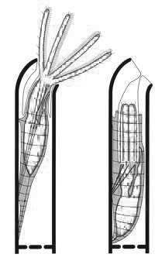

**Working in groups you should examine representative of all clades available. After doing so you should compare and contrast the morphology of the three clades in your journal.**

**Bryozoa (moss animals) are colonial lophophorates.** Colonies are composed of individuals, or zooids, which are usually less than 0.5 mm in length. Each zooid inhabits a secreted box, the zooecium, into which is can retract. Because of their small size, hemal, excretory, and respiratory systems are absent.

Colonies are usually attached to firm substrata and may be encrusting layers a single zooid thick, or more leaflike (bushy) and branching. Bryozoans often resemble seaweeds (or mosses) with which they are frequently confused by the public.

.

**1. External Anatomy of a typical bryozoan**.

**Colony Morphology**

Place a section of the colony of *Bugula or other species available,* in a finger bowl of seawater. Do not leave the rest of the colonies without water, and do keep the colony you are transferring in water. Add sea water so that your smaller bowl is almost full of water. Place the dish on the stage of the dissecting microscope and begin your observations with low power.

a. **Examine the colony for organsims that are using the bryozoan colony as substratum. What animals do you see? Obtain photographs of some of these inhabitants.**

The colony itself is composed of branching stems . The central stem of the bush is attached firmly to some hard substratum (in life). The colony is made of large numbers of typical feeding zooids called **autozooids**. There may also be a variety of specialized zooids, known as heterozooids, modified for functions other than feeding. Before examining the internal anatomy, add some fine suspension food to your colony. Phytoplankton or micro verts, (not the larger macro vert food), and try to focus on some autozooids on high power to see them feed.

**b. Film autozooids moving in and out of their case if you can.**

Look for heterozooids or zooids that are modified for other functions besides feeding, with high power of the dissecting microscope. Many autozooids bear hemispherical ovicells, or ooecia, at their distal, or free, ends **. Ooecia are highly modified heterozooids which serve as brood chambers for the adjacent autozooid.** A single egg is brooded in each ooecium**. Look for embryos in the ooecia. Colonies may be shedding larvae. They look like fast moving brown balls. Examine these later under the light microscope.**

Some *Bugula* species have **avicularia**. These are defensive heterozooids shaped like the head of a diminutive raptorial bird . Avicularia are specialized for discouraging predation and settling by the larvae of fouling organisms. They are attached to the sides of the autozooids and have a pair of mandibles to pinch predators or larvae. **Do a web search for these, since our colonies do not have them.** Note the large bulbous "cranium" with fixed upper and movable lower mandibles. The cranium is the zooecium of the heterozooid whereas the movable lower mandible is its operculum. **Try to find some pictures of open and some closed avicularia.**

c. Note any heterozooids found in the colony in your journal.

**2. Internal anatomy of a bryozoan. Now you are ready to examine individual zooids under the light microscope. Cut off a small branch of the colony and place on a depression or regular slide. Examine feeding and the internal structures of an autozooid under low power of the light microscope. The youngest and most transparent zooids are at and near the free tips of the branches.** The stems and bases of the branches consist largely of another type of heterozooid known as kenozooids. In *Bugula* the kenozooids are simply the empty zooecia of dead autozooids but, although dead, they continue to be important structurally in anchoring the colony to the substratum.

As you watch suspended particles in the water near the lophophore, note how they move with respect to the lophophore. Do the particles enter by passing between the tentacles or do they come in through the open base of the funnel and exit between the tentacles? Watch for motion of the tentacles, especially the characteristic "flicking" of bryozoan tentacles. What effect does the flicking have on particles?

**How many of the internal structure can you identify? c. Take photographs or short movies as desired.**

**Use the descriptions below to help you identify structures. You should label an individual zooid and its lophophore on a photograph or simply submit a short movie of water moving past the tentacles.**

**Use the description and figures below to help you as you examine your Bryozoans.**

The anatomy of a *Bugula* sp.

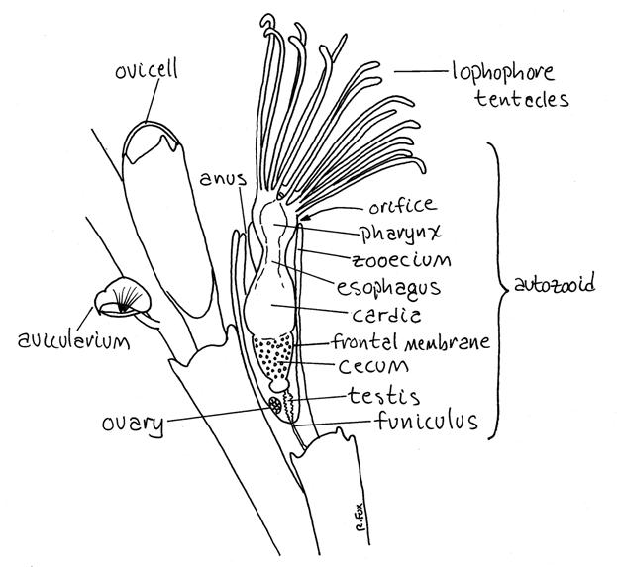

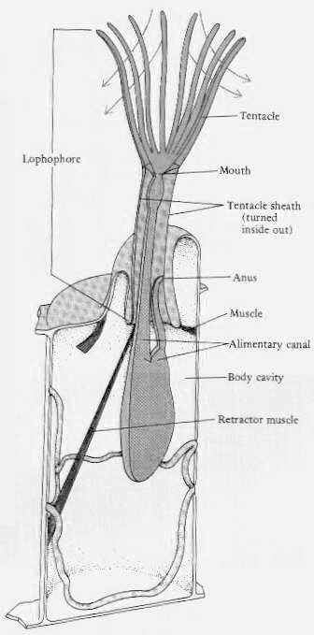

**Zooecium**

Each bryozoan zooid secretes and inhabits a nonliving zooecium (zoo = animal, oikos = house). The zooecium is secreted by the epidermis of the zooid’s body wall and In Bugula consists of lightly calcified chitin. They are elongate and transparent.

One wall of the zooecium of autozooids is thin and uncalcified. This wall is the frontal membrane . The transparency of the frontal membrane renders the internal structures visible. The frontal membrane of Bugula has the shape of a deep "V" or "U" and covers one side of the **zooecium**. Look carefully at the surface of some of the autozooids near the tips of the branches and find the long U-shaped frontal membrane extending almost the entire length of the zooecium . You may have to turn the branch over to see the membrane. The frontal membranes of all the zooids of a given branch will be on the same side of the branch.

Movement of the frontal membrane inward puts the coelomic fluid under pressure and everts the feeding tentacles, or lophophore. The lophophore is retracted by special retractor muscles . The zooid inhabits the interior of the zooecium but the feeding tentacles can be extended from its open end. The opening through which the lophophore is extended is the orifice. The orifice is at the distal end of the zooecium and in Bugula lacks an operculum.

Lophophore

The anterior end of the zooid can be everted from the orifice and you should be able to find some individuals in which this has happened. The everted portion of the zooid is the introvert, consisting of the **lophophore** and anterior end of the metasome. When extended, the tentacles of the lophophore are graceful and conspicuous.

Look for a zooid whose lophophore is extended. The inner surfaces and sides of the tentacles are ciliated but the outer surface is not. The cilia on the two sides of each tentacle are the lateral cilia. They generate the current that moves water and food particles in the open end of the lophophore and then out between the tentacles. **The cilia on the inner edge of the tentacle are the frontal cilia. Their responsibility is to move captured food toward the mouth Food particles are retained inside the cone and then moved to the mouth by the frontal cilia**.

Digestive System

The largest and most obvious organ system is the digestive system. **It is U-shaped with both mouth and anus at the anterior end of the zooid.** **The mouth is at the apex of the lophophore and is at the center of the ring of lophophoral tentacles**. The mouth opens into a large muscular pharynx.

The **pharynx** leads to a large, usually brown esophagus. The large three-part stomach follows the esophagus and occupies the bottom of the loop of the U-shaped gut. The intestine extends anteriorly from the pylorus to the anus situated on the dorsal midline but outside the lophophore. The pharynx, esophagus, and cardia are the descending limb of the “U” whereas the pylorus and intestine are the ascending limb. The walls of the cecum usually contain numerous tiny brown inclusions, which give it a dark brown color. These inclusions accumulate and increase as the zooid ages. They are thought to contain wastes and will eventually be incorporated into a brown body for disposal.

Funicular System

A **funiculus** composed of short, transparent, cellular funicular cords extends from the proximal end of the cecum to the posterior end of the zooid. The cords are in contact, across pores in the zooecium, with similar cords in other zooids. The funicular system is an interzooid transport system.

_____________________________________________________________________________________

**3. External anatomy bryozoan larvae. Often colonies going dormant will shed larvae. Bryozoan larvae are unique and do not look like the larvae of any other clade.**

Following fertilization, larvae are produced which show wide variation in body form from species to species. The larvae of non-brooding bryozoans feed during the larval stage, while the larvae of brooding bryozoans do not, since these larvae tend to settle soon after release. The most common larval type in bryozoans is the cyphonautes larva ,which is somewhat triangular in shape and has an apical tuft of cilia. Another type of larvae found is known as a arborescent type. It looks like a ball with a ciliated cap on its top. Upon settling, larvae attach via adhesive sacs and undergo [metamorphosis](http://www.sms.si.edu/irlspec/IntroBryozoa.htm" \l "metamorphosis) to the adult form. The first zooid in a colony is called the ancestrula. It is from this individual that the rest of the colony will grow asexually from budding.

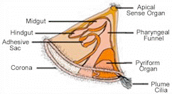

Cyphonaute larvae

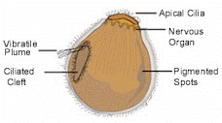

Arborescent larave.

**What type of larvae is being produced by this colony? How does it move? Try to film movement in any larvae you find.**

**Exercises four - six: Phoronida**

Phoronida is a small taxon of 14 worm-shaped lophophorates. They are benthic, infaunal or epifaunal, marine suspension feeders. When conditions are favorable they may be present in high population densities . They secrete and inhabit a stiff chitinous tube and have a horseshoe-shaped (usually) or circular lophophore. Sand, shell fragments, debris, sponge spicules, and other particles may adhere to the chitinous tube.

The body consists of two regions, each containing a coelomic space . The mesosome with its mesocoel is larger and is the region of the lophophore. It surrounds the mouth as a coelomic ring with extensions into the tentacles of the lophophore. Most of the body is the metasome, or trunk, and its cavity is the metacoel, or perivisceral coelom, or the trunk coelom. The metacoel is partitioned by four longitudinal mesenteries into four compartments. A third region, the small anterior epistome overhangs the mouth.

The long gut is complete and extends from the anterior, terminal mouth to the subterminal, also anterior, anus situated on the dorsal midline near the anterior end and just above the mouth. The closed hemal system contains hemoglobin in corpuscles. The lophophore is the major respiratory structure. Two metanephridia open through nephridiopores beside the anus . The nervous system includes a nerve ring at the anterior end and a longitudinal nerve cord on the left side (usually).

Phoronids may be gonochoric but most are hermaphroditic. Fertilization is internal. The larva is an actinotroch, a type of trochophore. Phoronids often undergo asexual reproduction which may result in aggregations of individuals. The individuals in the aggregation may be entangled with each other.

**4. External anatomy of a phoronid.**

Phoronids are not often available in teaching laboratories but we may be very lucky and have some specimens. Our species, *Phoronis architecta* inhabits shallow (high subtidal) silty sand bottoms and constructs a straight, sandy, chitinous tube about 10 cm in length and about 1-2 mm in diameter**. Place a specimen in a finger bowl or plastic box that has a bit of sand on the bottom. a. Take a photograph of a specimen under high power of the stereoscope and label the area of the tube containing the worm. Determine how much of the tube contains the main portion of the worm.**

**5. Phoronid feeding. You will need to be lucky enough to choose an active feeding worm. If your worm is active, please make sure your classmates view your specimen. Add a bit of fine food to the specimen.**

**Does the motion of particles through the lophophore of your animal conform to the description below?** **Visualize the pattern of current flow by watching the movement of the small suspended food particles in the water. b. Obtain a movie under high power of your stereoscope of feeding in your specimen.**

Find the lophophore and note that its tentacles are arranged in a horseshoe shape, rather than a simple circle . The mouth is at the bottom (apex) of the lophophore encircled by the ring of tentacles. The feeding current is generated by the lateral tentacular cilia and food particles are transported to the mouth by the frontal cilia. Water enters the open end of the lophophore and exits laterally between the tentacles and out of the lophophore. Food particles in the exiting current strike the tentacles and initiate a local reversal of beat in the lateral cilia on the sides of the tentacles which throws them back into the bell. This may happen several times before they eventually strike the frontal cilia on the inside edge of the tentacles and are moved by them toward the mouth. There are no cilia on the outside edges of the tentacles.

6.  **Internal anatomy of a phoronid**

**You will need an active worm that moves the lophophore to be able to locate certain organs and observe movement in the blood vessels**. If your worm is not active, simply place it back in culture and use a neighbor’s worm. **However, if no worms are active, the instructor may sacrifice one or two so that you can see internal structure. It may take a while for the phoronids to get active. They prefer darkness and cool water, so allow your worm to adjust with lights off and watch temperatures in small dishes.**

Begin your study of the worm using the lophophore to orient yourself. It is located ventrally on the anterior end of the animal. The mouth is displaced to the ventral side of the anterior end and is surrounded by tentacles. Look for blood flow by watching for movement of cells containing pigment throughout the body.

If the lophophore is extended, observe it and note the arrangement of tentacles around the mouth. The red color is due to hemoglobin in erythrocytes in the blood vascular system.

**a. blood vessels** . The red color of their corpuscular hemoglobin makes blood vessels easy to see in living specimens. They are connected to circular blood vessels at the base of the lophophore. Tentacular vessels extend from the circular vessels into each tentacle of the lophophore. At the posterior end of the trunk the dorsal and ventral vessels are connected to a plexus, or "capillary" bed in the wall of the gut and gonads. Would you classify the circulation as “closed” or “open?”

**b. Try to find the gut, which is a long "U" with one limb descending from mouth down into the trunk to the ampulla and the other limb ascending back to the anus.**

**c. Obtain a video or take photographs of blood moving into the lophophore. Use arrow to show blood moving in and out of major vessels in your photograph. Also label the digestive system. If instead filming, try to show blood moving into the lophophore and around the gut in your video.**

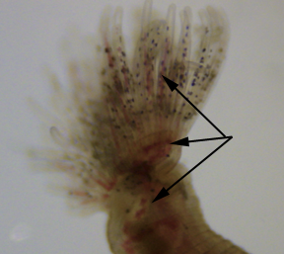

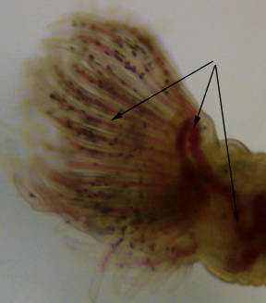

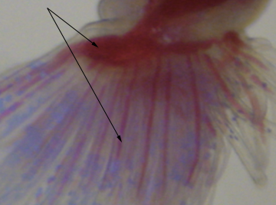

**The description below is provided to help you identify structures during your examination.**

**________________________________________________________________________________________**

The epistome forms a ridge overhanging the mouth dorsally. It contains a space that some believe is homologous to the protocoel of the early deuterostomes.

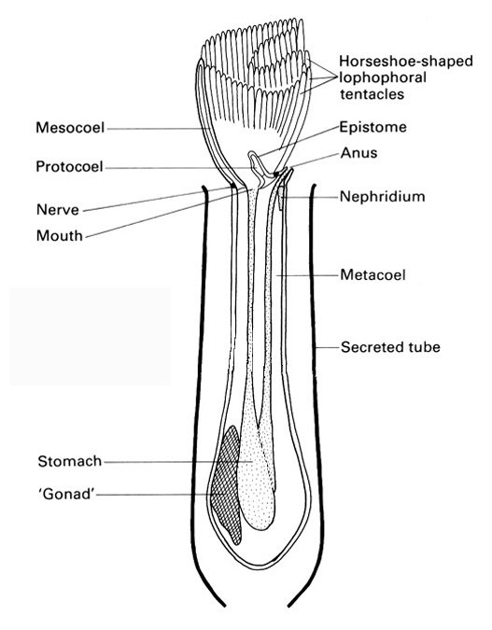

Ventral to the epistome is a ciliated groove that conveys food particles from the bases of the tentacles to the mouth. Look for food particles in transport along this groove. A little phytoplanton suspended in seawater might help visualize the role of the groove.

Look dorsal to the epistome and mouth for the anus, which is located outside the lophophore and just dorsal to it, between the arms of the horseshoe . The anus is located on the midline and is flanked by the openings of the two metanephridia, the nephridiopores. You probably will not see the nephridiopores.

**The long trunk, or metasome, of the phoronid accounts for most of the body and contains the spacious metacoel, or trunk coelom . The posterior end of the trunk is slightly swollen to form an ampulla.**

A long glandular esophagus extends from the mouth down the trunk to the expanded stomach located in the posterior end just before the gut reverses its direction. The intestine exits the stomach at the bottom of the “U” and is the ascending limb of the gut tube. It ends at the anus.

Phoronids may have separate sexes or be hermaphroditic but our specimens, *P. architecta have separate sexes* . The gonads are located in the metacoel on the posterior end of the esophagus. Gametes are released from the gonads into the metacoel where they mature and are stored. Eventually they are fertilized and released through the metanephridia and nephridiopores. The trunk coelom may contain eggs or zygotes.

**If the metacoel appears to contain gametes, open it to release them into a small dish of clean seawater**. Make a wetmount of the gametes. Examine the preparation with the compound microscope. Determine if the gametes are eggs or sperm. Eggs are large, immobile, and yolky. Sperm are tiny, flagellated, and mobile. If they appear to be "eggs" they could actually be zygotes or early embryos. Monitor the development of the embryos in the wetmount for as long as they live and then turn your attention to the embryos in the dish. If you are fortunate, they may develop into actinotroch larvae (see below) .



